**Name: Sunil Kunwar Roll No.: 114 IIB Date: 2080-05-05**

**M. Sc. 2nd Semester General Lab – 09**

**STUDY THE PHOTOCELL AND VERIFY INVERSE SQUARE LAW. HENCE DETERMINE PLANCK’S CONSTANT.**

**APPARATUS REQUIRED**

1. Experimental set up for measurement of Planck’s constant
2. Filters of different colors (Red, Green, Blue, Yellow)

**THEORY**

Most of the metals under influence of radiation, emit electrons. This phenomenon is termed as photoelectric emission. The detailed study of it has shown:

1. That the emission process depends strongly on frequency of radiation.
2. For each metal there exists a critical frequency such that light of lower frequency is unable to liberate electrons, while light of higher frequency always does.
3. The emission of electron occurs within a very short time interval after arrival of the radiation and number of electrons is strictly proportional to the intensity of this radiation.

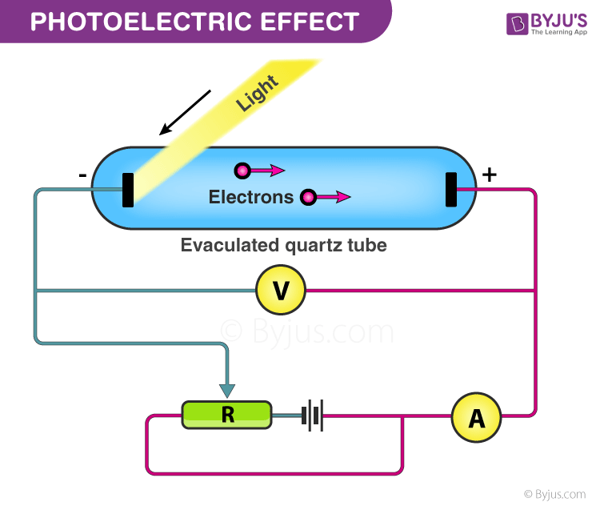

*Figure 1: Experimental set up Photoelectric Effect*

The experimental facts given above are among the strongest evidence that the electromagnetic field is quantified and the field consists of quanta of energy where is the frequency of the radiation and is the Planck’s constant. These quanta are called photons. Further it is assumed that electrons are bound inside the metal surface with an energy , where is called the work function. It then follows that if the frequency of the light is such that , it will be possible to eject photoelectron, while if it would be impossible.

In the former case, the excess energy of photon appears as kinetic energy of the electron, so that:

|  |  |
| --- | --- |
|  |  |
|  |  |

which is the famous photoelectric equation formulated by Einstein.

If we apply a retarding potential so as to stop the photo electrons completely, it is known as stopping potential . At that instant:

|  |  |
| --- | --- |
|  |  |

|  |  |
| --- | --- |
| From equation (2) and (3), |  |
|  |  |
|  |  |

So, when we plot a graph as a function of , the slope of the straight-line yields and the intercept of extrapolated point at gives work function .

**To verify inverse square law of radiation using a photoelectric cell.**

If is the luminous intensity of an electric lamp and is the illuminiscence (intensity of illumination) at point from it, then according to inverse square law.

|  |  |
| --- | --- |
|  |  |

If this light is allowed to fall on the cathode of a photo-electric cell, then the photo-electric current (I) would be proportional to E.

|  |  |
| --- | --- |
|  |  |

From equation (6) and (7) graph between and is a straight line, which verify the inverse square law of radiation.

**OBSERVATION**

**Table 1:** For the determination of Planck’s constant ().

|  |  |  |  |
| --- | --- | --- | --- |
| **SN** | **Filters** | **(Hz)** | **Stopping Voltage ( in Volts) at d = 30 cm** |
|
|  | Red (635 nm) | 4.72 | 0.28 |
|  | Yellow I (570 nm) | 5.26 | 0.49 |
|  | Yellow II (540 nm) | 5.56 | 0.64 |
|  | Green (500 nm) | 6.00 | 0.82 |
|  | Blue (460 nm) | 6.50 | 0.99 |

**Table 2:** For verification of inverse square law

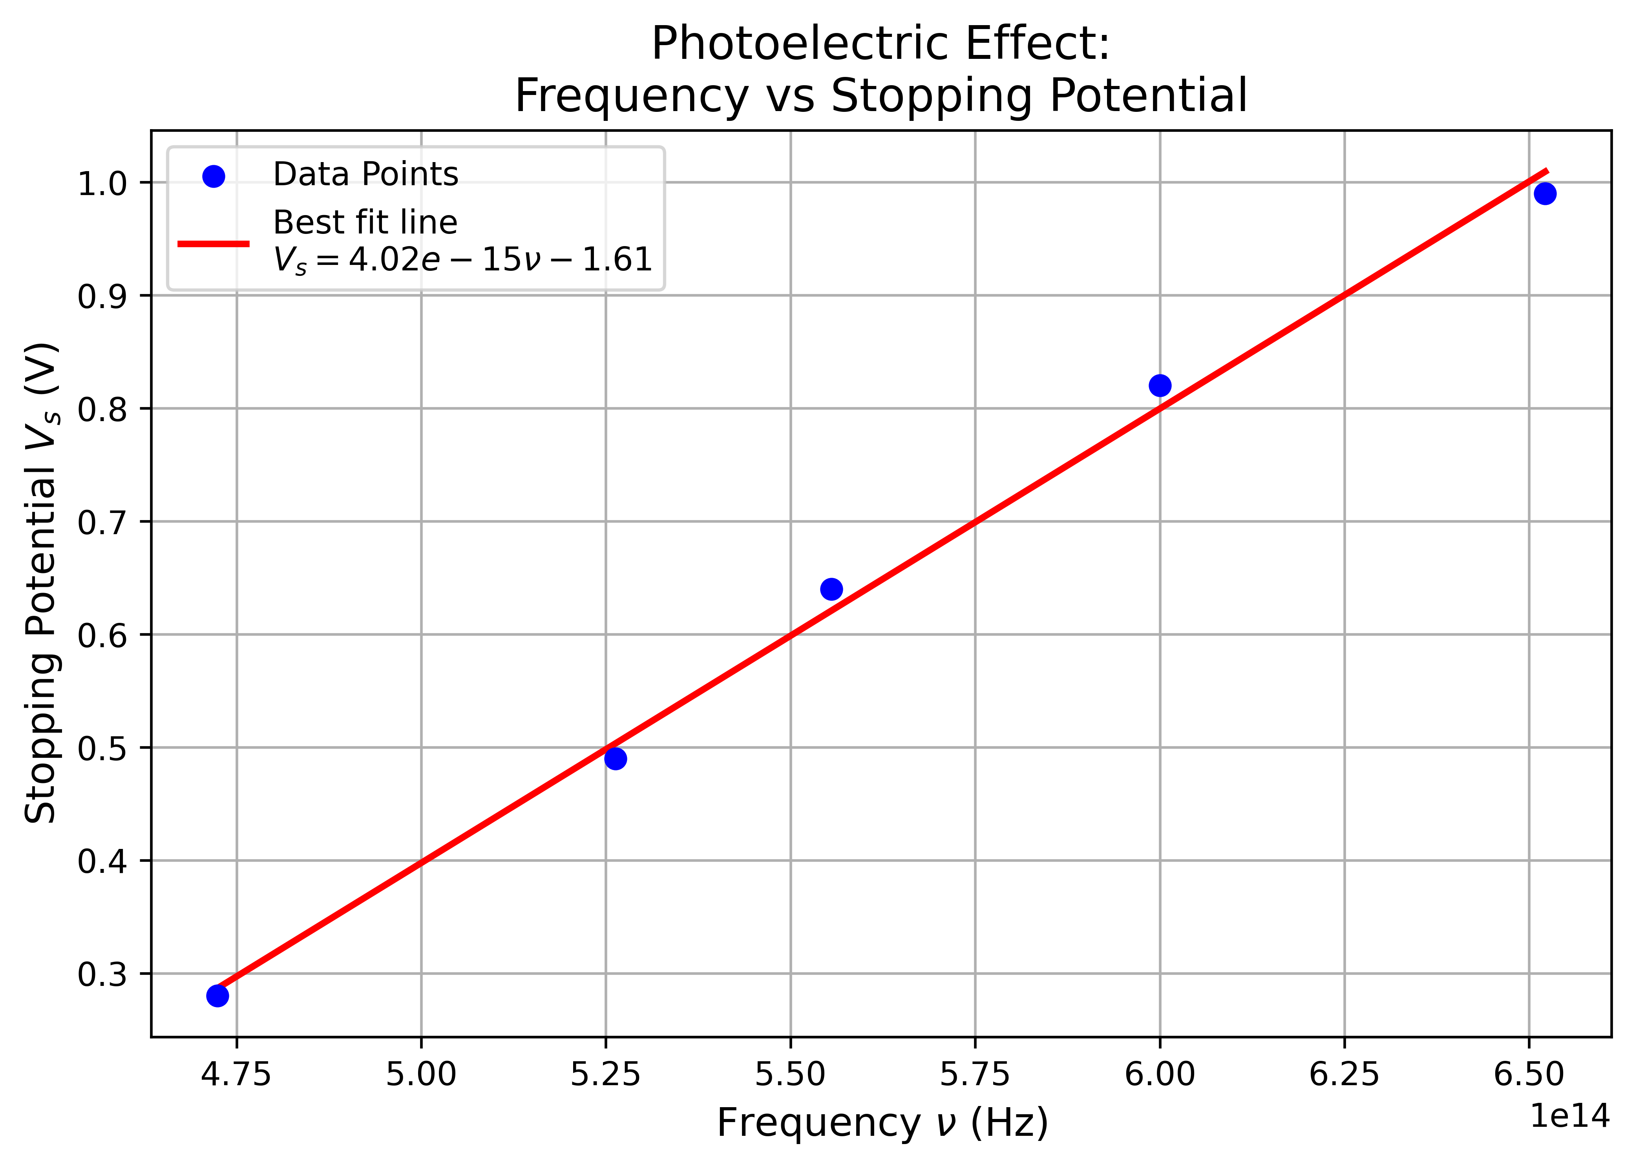

*Figure 2: Frequency vs stopping potential and best fit line.*

|  |  |  |  |  |  |  |
| --- | --- | --- | --- | --- | --- | --- |
| SN | Distance in cm (r) | ( | Current () | | | |
| Blue | Green | Yellow | Red |
|  | 16 | 3.906 | 5.13 | 4.49 | 2.98 | 1.16 |
|  | 18 | 3.086 | 4.45 | 3.91 | 2.54 | 0.99 |
|  | 20 | 2.500 | 3.54 | 3.11 | 2.03 | 0.76 |
|  | 22 | 2.066 | 2.86 | 2.44 | 1.61 | 0.61 |
|  | 24 | 1.736 | 2.40 | 2.10 | 1.36 | 0.51 |
|  | 26 | 1.479 | 2.10 | 1.81 | 1.19 | 0.44 |
|  | 28 | 1.276 | 1.87 | 1.60 | 1.04 | 0.39 |
|  | 30 | 1.111 | 1.67 | 1.42 | 0.94 | 0.35 |
|  | 32 | 0.977 | 1.50 | 1.29 | 0.85 | 0.31 |
|  | 34 | 0.865 | 1.38 | 1.17 | 0.78 | 0.29 |
|  | 36 | 0.772 | 1.28 | 1.07 | 0.73 | 0.26 |
|  | 38 | 0.693 | 1.19 | 1.03 | 0.68 | 0.24 |
|  | 40 | 0.625 | 1.11 | 0.96 | 0.63 | 0.23 |

**CALCULATION**

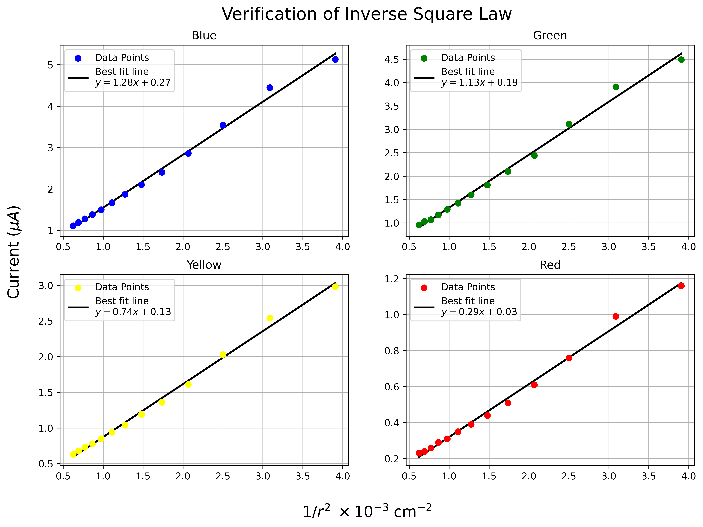

*Figure 3: Inverse square of distance vs current and best fir graph.*

From figure 1,

Slope of best fit line =

From equation (5),

Slope =

**ERROR ANALYSIS**

Comparing with

and

**Table 3:** Error analysis for Planck’s constant (h).

|  |  |  |  |  |  |
| --- | --- | --- | --- | --- | --- |
| **SN** |  | ***y*** |  |  |  |
|  | 4.72 | 0.28 | 1.90 | 0.7885 | 2.6161 |
|  | 5.26 | 0.49 | 2.11 | 0.1211 | 2.6391 |
|  | 5.56 | 0.64 | 2.24 | 0.0023 | 2.5444 |
|  | 6 | 0.82 | 2.41 | 0.1537 | 2.5345 |
|  | 6.5 | 0.99 | 2.61 | 0.7957 | 2.6341 |
|  |  |  |  | **D=∑**  **=1.8613** | **∑** |

Mean

So,

**RESULT**

Hence, the value of Planck’s constant is determined to be .

**CONCLUSION**

The experiment to study the photocell and verify the inverse square law demonstrates the relationship between the intensity of light and the distance from the source. The results confirm that the intensity of light decreases proportionally to the square of the distance, validating the inverse square law.

By analyzing the photoelectric effect using the photocell, the threshold frequency for the material was determined, and Planck’s constant was calculated. The experimentally obtained value of Planck’s constant is .

………………

(Signature)